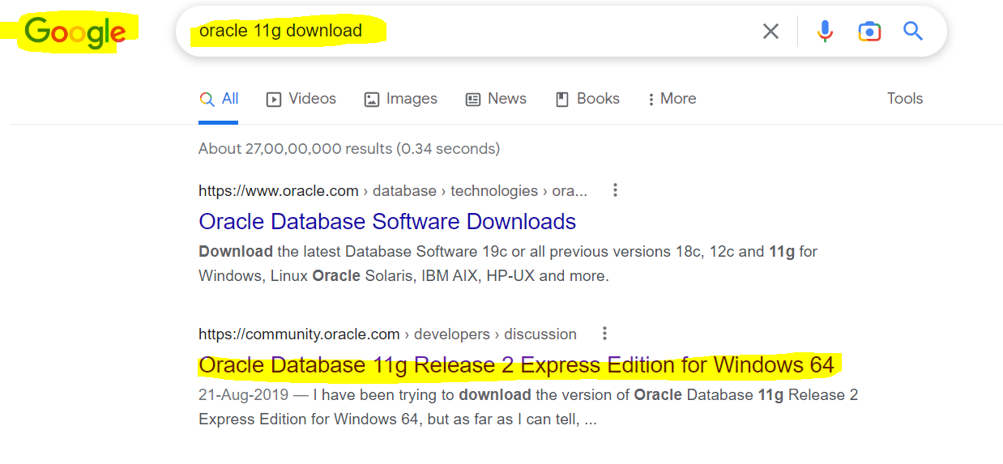

Open the link and scroll down and search for below link and open it

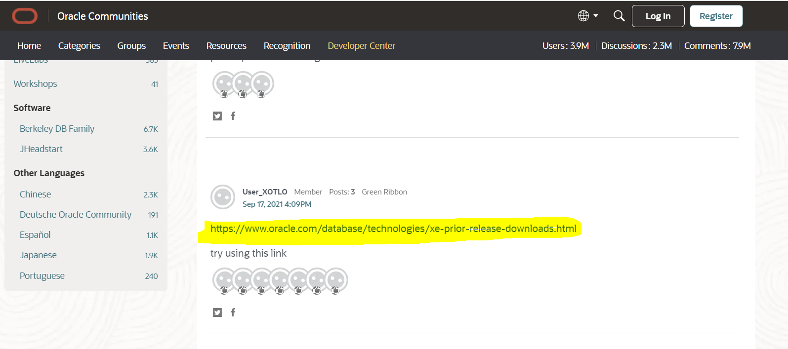
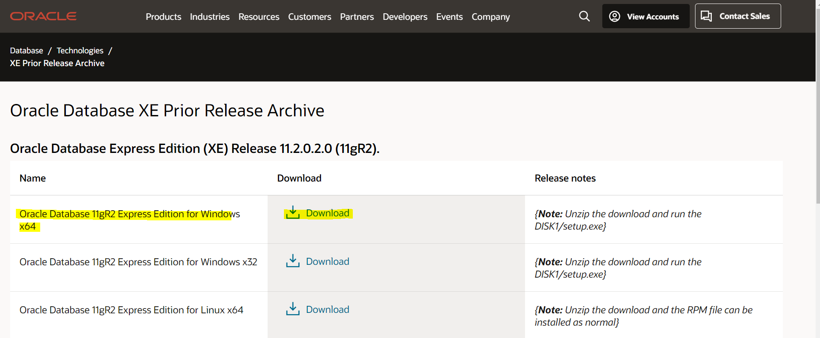

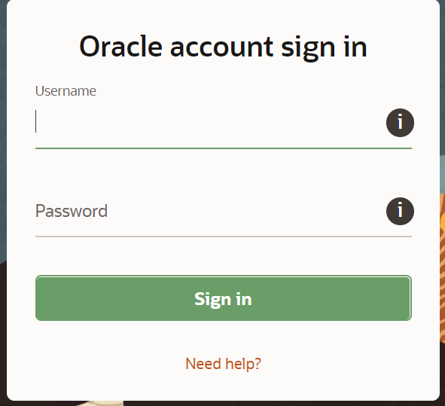

It will ask for oracle account so provide login details and download will start automatically
Once download completed go to Download folder and extract the file
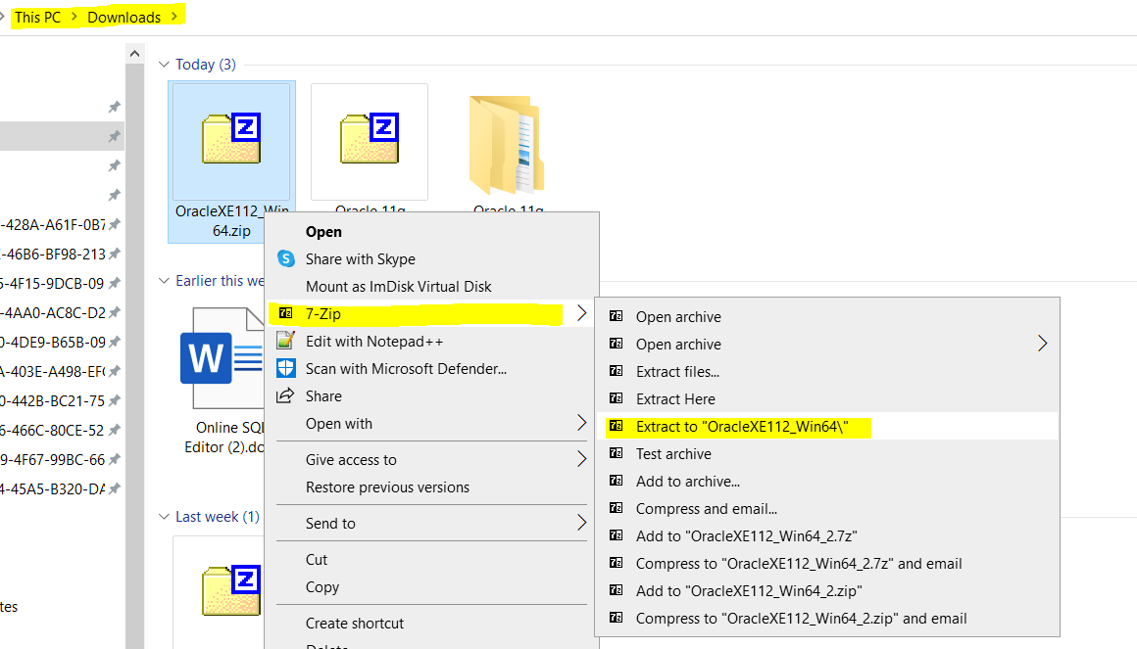
Open the extracted file and double click on setup.exe
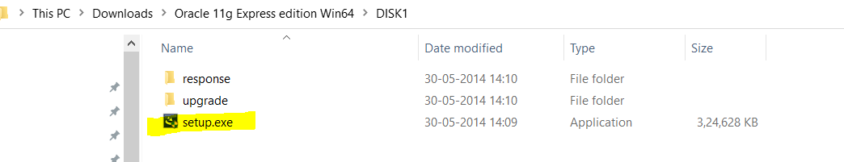

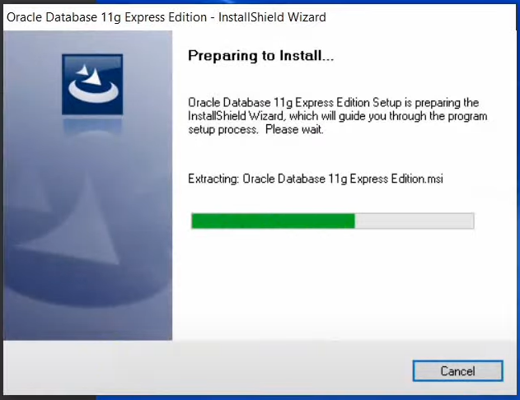

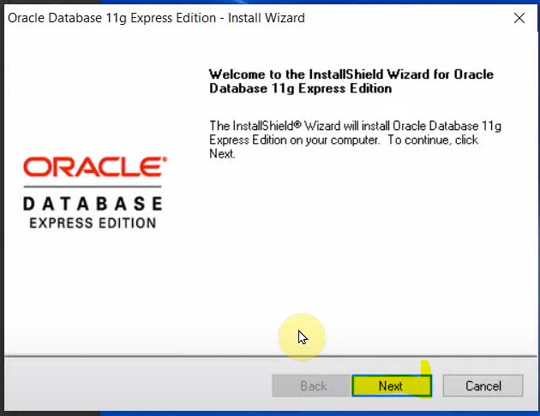

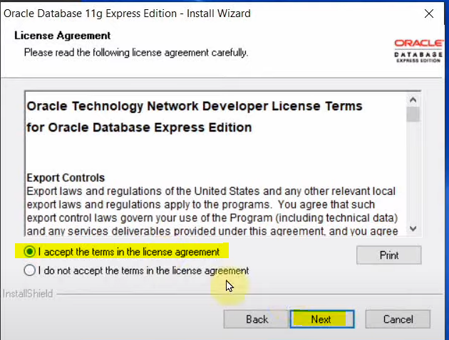

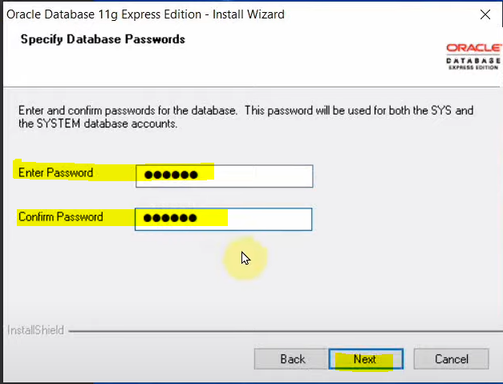
Note – Please note this or remember the password, this is SYSTEM password which will be use at the time of Connection to SYSTEM USER.
you can provide ‘oracle’ as password.
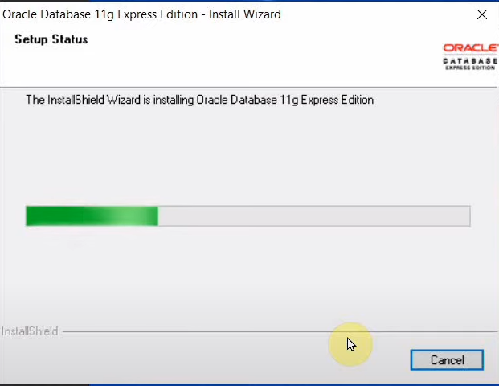

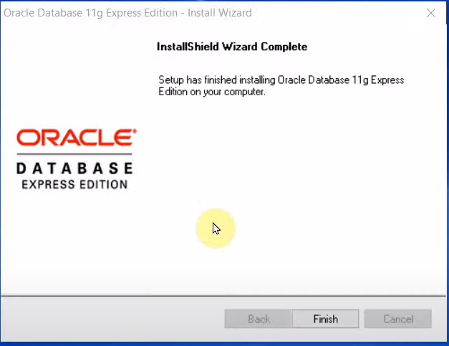

Click on Finish

Now open window search box and type SQL and open Run SQL Command Line
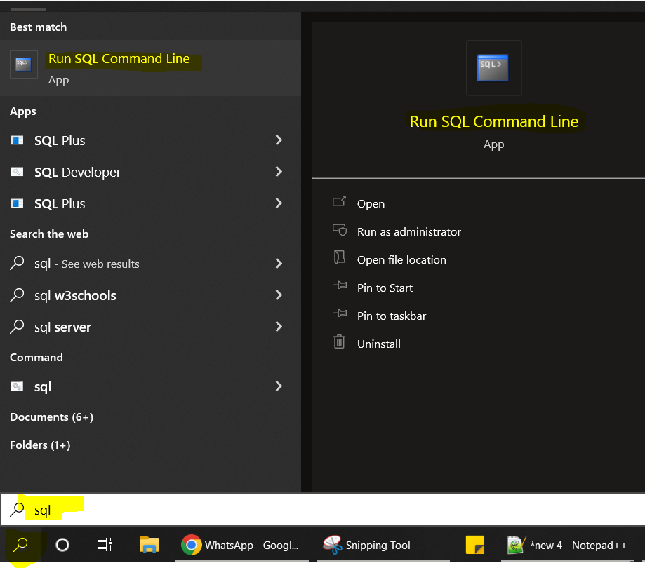

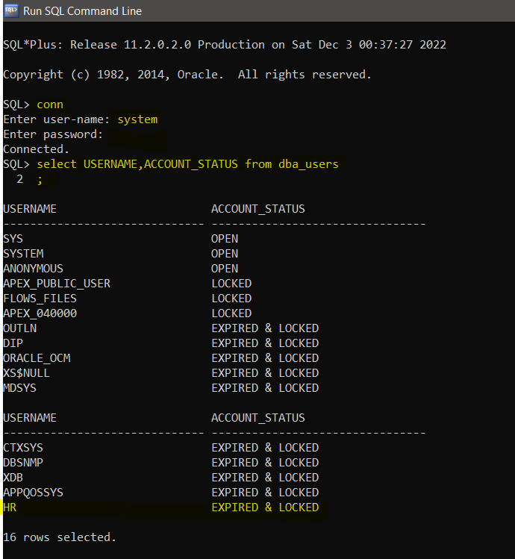
Provide the system password which you have provided at the time of installation

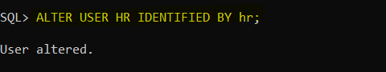
Here User name is HR and password is hr
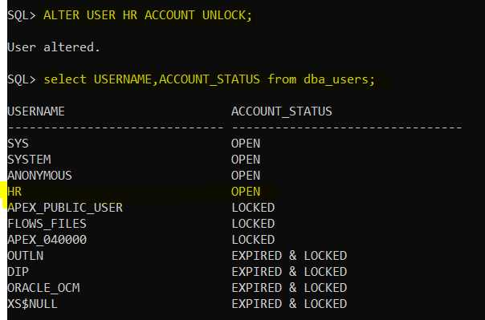

Connation through SQL Developer

Now Install SQL Developer on Windows 10
Click or Go to Below link to download the SQL Developer-
https://www.oracle.com/tools/downloads/sqldev-downloads.html

Click on Download -
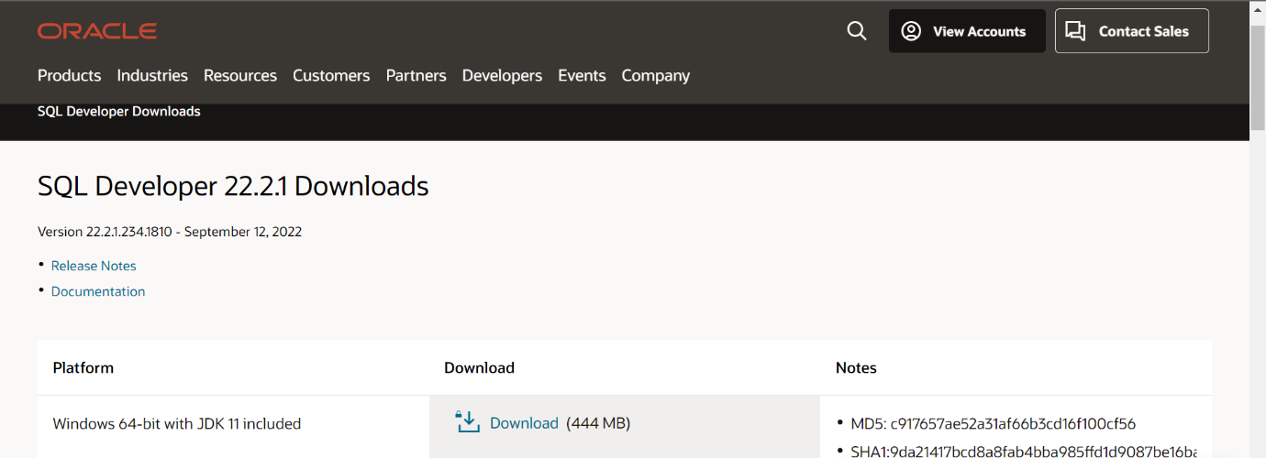

Accept the Agreement and click on Download SQL developer button-
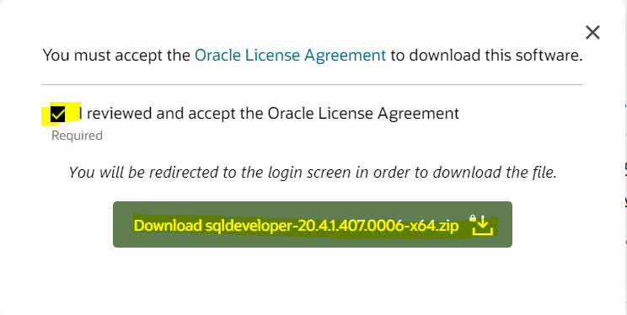
Once download completed – copy the zip file from download folder into other drive folder and extract its content there.

Now Open the folder and right click on sqldeveloper.exe file and Run As Administrator
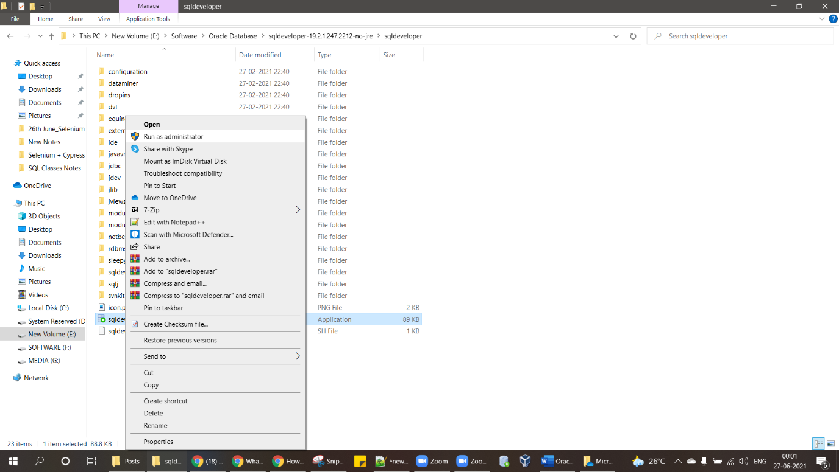

It will start Installing sql developer
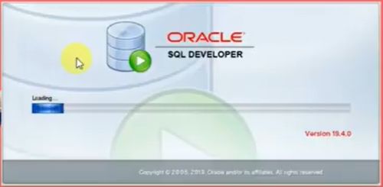
Click on OK
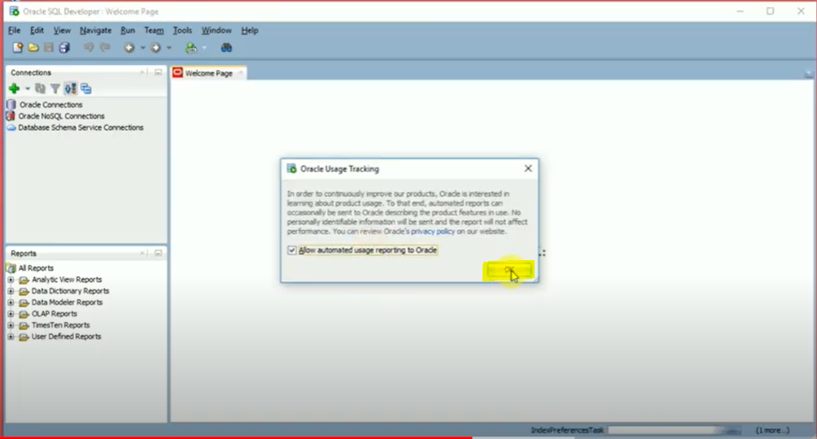

Click on + Symbol to create connection with Database -
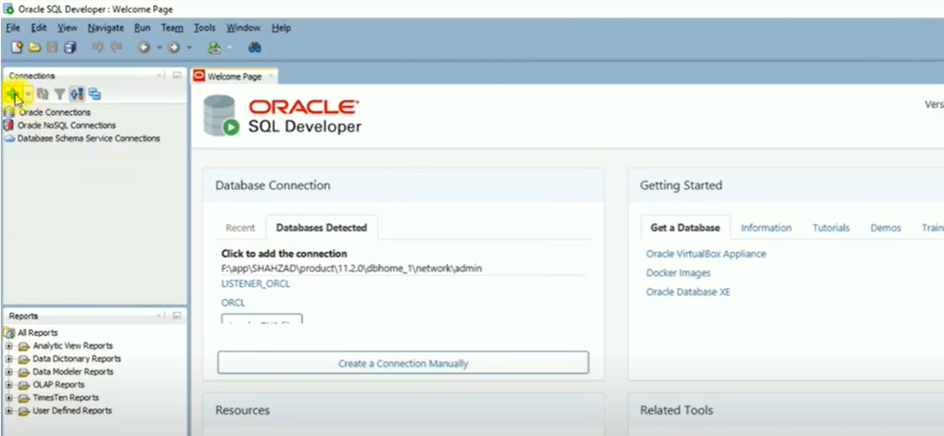

Connection using SQL Developer to SYS or SYSTEM User
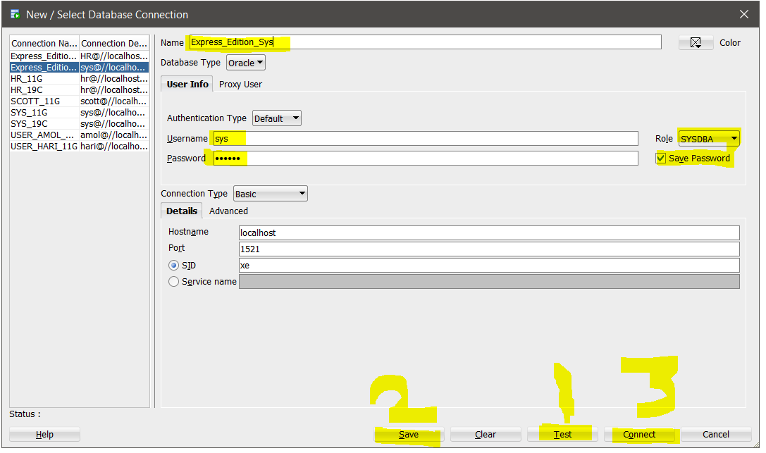

Name – Any Suitable Name
Username – sys
Password – Provide the password which we provided at the time of installing Database
Hostname – keep As it is, No need to change
Role – Select SYSDBA from Drop down
Click on Save Password
First Click on Test Button
Second Click on Save Button
Third Click on Connect Button

Connection using SQL Developer to HR User

